Johnathan Rizzi
CIS 9440
Assignment 1

Deliverables:
- Data Sourcing
  - Link to All Data Sources - https://data.texas.gov/dataset/Mixed-Beverage-Gross-Receipts/naix-2893/data_preview
  - Web API - https://data.texas.gov/resource/naix-2893.csv
  - Connection to Database – Amazon AWS RDS – Endpoint - cis-9440-assignment-1.c926uuogo706.us-east-2.rds.amazonaws.com
  - Connection to Data Store (Cloud Storage) – Amazon S3 Storage - s3://mixed-beverage-data/raw/mixed_beverage_gross_receipts.csv
  - Git Repository (set to public) - https://github.com/jrizzi98/CIS-9440---Assignment-1.git
  - Data Dictionary (in git) - https://github.com/jrizzi98/CIS-9440---Assignment-1/blob/main/Mixed%20Bev%20Data%20Dictionary.xlsx
  - Script (.py in git) - https://github.com/jrizzi98/CIS-9440---Assignment-1/blob/main/texas_data_pull.py

- Storage
  - Storage of choice – Storage S3 AWS
  - Updated Scripts (.py in git) - https://github.com/jrizzi98/CIS-9440---Assignment-1/blob/main/Data%20Upload%20and%20Modeling.py
  - Data is stored in orderly fashion in storage and git repository updated.
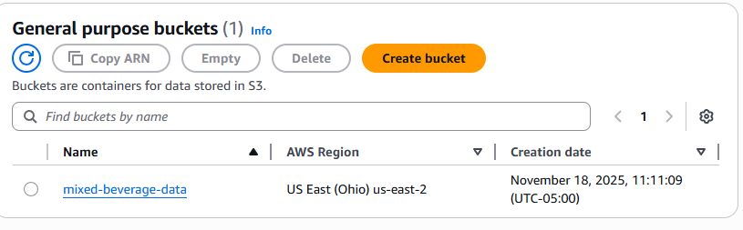
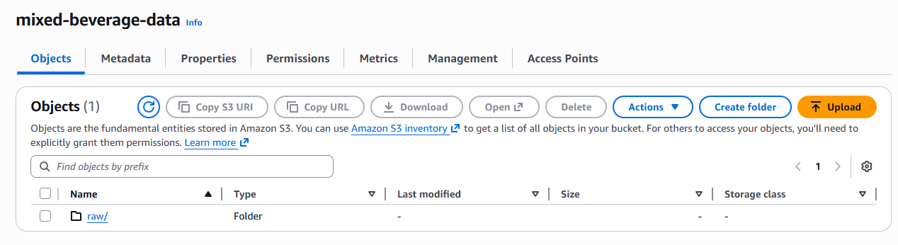
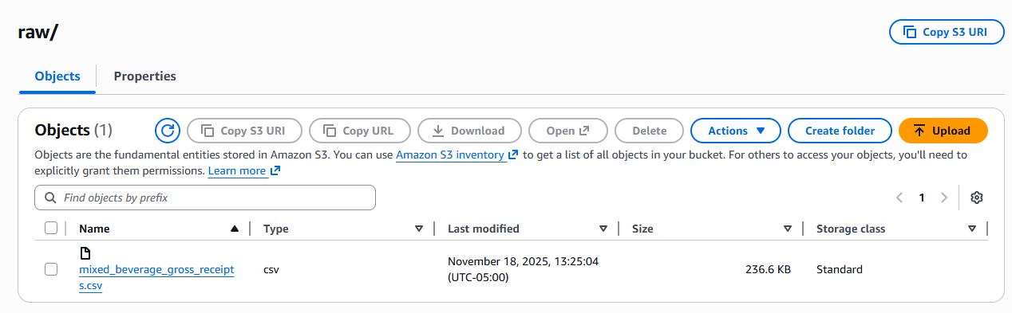
- Modeling
  - Updated Scripts (.py in git including modeling) - https://github.com/jrizzi98/CIS-9440---Assignment-1/blob/main/Data%20Upload%20and%20Modeling.py
  - Modeling Lucidchart (in git) - https://github.com/jrizzi98/CIS-9440---Assignment-1/blob/main/Modeling%20Lucidchart.png
  - Data Warehouse model contains fact and dimension tables. Surrogate keys included.

